**Name : Kumar Ayush**

**Roll : 21051737**

**CSE-18**

**OPP Lab Assignment : 1**

**Q.1. Write a program in C++ to print hello on the screen.**

#include <iostream>

using namespace std;

int main (){

    printf("Hello");

    return 0;

}

**OUTPUT**

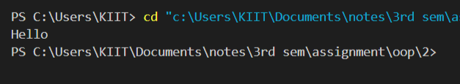

**Q.2. Write a C++ program to find prime numbers between 1-1000. [Create a prime() function]**

#include <iostream>

using namespace std;

void prime(int n);

int main(){

    int n ;

    printf("enter the no. till where you want to find prime no.");

    cin>>n;

    prime(n);

    return 0;

}

void prime(int n){

    printf("the prime no. between 1 to %d are :",n);

    for (int i=3 ; i<=n ; i++){

        int c=0;

        for(int j=2 ; j<=i/2 ; j++){

            if (i%j==0)

            c++;

        }

        if(c==0)

        printf(" %d",i);

    }

}

**OUTPUT**



**Q.3. Write a C++ program to take two numbers from the command line argument and sum both**

**these numbers and display the output. [Hint: use atoi() function to convert a char array to**

**integer].**

#include <iostream>

#include <stdlib.h>

using namespace std;

int main(int argc ,char const *argv[]){

    int sum=0 , a=0;

    for(int i=1 ; i<argc ; i++){

        a=atoi(argv[i]);

        sum=sum+a;

    }

    cout<<"\n\nsum : "<<sum;

    return 0;

}

**OUTPUT**

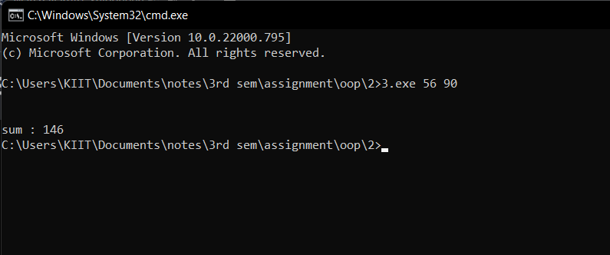

**Q.4. Create a class which stores name, roll number and total marks for a student. Input the**

**data for a student and display it.**

#include <iostream>

using namespace std ;

class{

    int roll;

    char name[25];

    int marks;

public :

    void input_details(){

        cout<<"\n\n\nenter student details : \n\n"<<"enter name : ";

        scanf("%[^\n]s",name);

        cout<<"enter roll : ";

        cin>>roll;

        cout<<"enter marks : ";

        cin>>marks;

    }

    void display_details(){

        cout<<"\n\n\nstudent details are :\nname : "<<name<<"\nroll :"<<roll<<"\nmarks :"<<marks;

    }

}s;

int main(){

    s.input_details();

    s.display_details();

    return 0;

}

**OUTPUT**

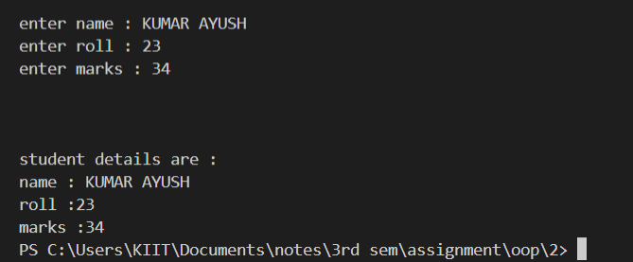

**Q.5. Modify the program 4) to store marks in 10 subjects. Calculate the total marks and**

**percentage of a student and display it.**

#include <iostream>

using namespace std ;

class student{

    int roll;

    char name[25];

    int marks[10];

    int total_marks=0;

    float prec;

public :

    void input_details(){

        cout<<"\n\n\n---------------------------enter student details------------------------------ \n"<<"enter name : ";

        scanf("%[^\n]s",name);

        cout<<"enter roll : ";

        cin>>roll;

        for(int i=0 ; i<10 ; i++){

            cout<<"enter marks of subject "<<i+1<<" : ";

            cin>>marks[i];

            total_marks=marks[i]+total_marks;

        }

        prec=(float)total_marks/10;

    }

    void display_details(){

        cout<<"\n\n\n--------------------------student details are :--------------------------------\nname : "<<name<<"\nroll :"<<roll<<"\nmarks of student in 10 sub are :";

        for (int i=0 ; i<10 ; i++)

        cout<<"\nsub "<<i+1<<" : "<<marks[i];

        cout<<"\ntotal marks : "<<total_marks<<"\n";

        printf("percentage : %2.2f",prec);

    }

}s;

int main(){

    s.input_details();

    s.display_details();

    return 0;

}

**OUTPUT**

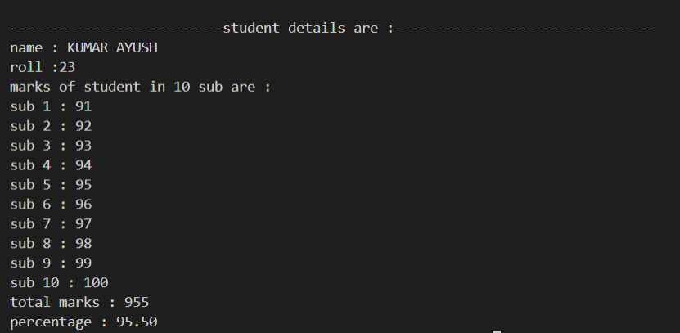

**Q.6. Create a class complex which stores real and imaginary part of a complex number.**

**Input 10 complex numbers and display them.**

#include <iostream>

using namespace std;

class complex_no{

    int real;

    int img;

public :

    void input(){

        cout<<"\nenter the real and and imaginary part respectively : ";

        cin>>real;

        cin>> img;

    }

    void display(){

        cout<<endl<<real<<" i"<<img;

    }

};

int main(){

    int n;

    cout<<"enter total no. of entries : ";

    cin>>n;

    complex_no c[n];

    cout<<"----------------enter "<<n<<" complex no.--------------------------\n\n";

    for(int i=0 ; i<n ; i++){

        cout<<"input : ";

        c[i].input();

    }

    cout<<"----------------"<<n<<" complex no. are : --------------------------\n\n";

    for(int i=0 ; i<n ; i++)

    c[i].display();

    return 0;}

**OUTPUT**

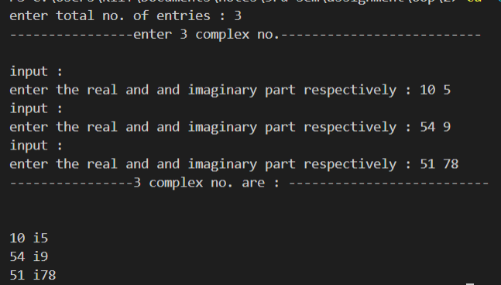

**Q.7. Create a class which stores x and y coordinates of a point. Calculate distance between two**

**given points and display it.**

#include <iostream>

#include <math.h>

using namespace std;

class cod{

public :

    int x;

    int y;

public :

    void input(){

        cout<<"\nenter x and y coordinate respectively : ";

        cin>>x;

        cin>>y;

    }

    void display (){

        cout<<"( " <<x<<" , "<<y<<" )";

    }

};

float dis(cod *p);

int main(){

    cod *p = new cod [2];

    for(int i=0 ; i<2 ; i++ ){

        cout<<"--------------enter details for point"<<i+1<<" : -----------------";

        (p+i)->input();

    }

    for(int i=0 ; i<2 ; i++){

        cout<<"\n point "<<i+1<<" is : ";

        (p+i)->display();

    }

    float d=dis(p);

    printf("\n the distance between point 1 and 2 is : %2.4f units",d);

    return 0;

}

float dis(cod *p){

        int x1 , y1 , x2 , y2 , a , b ;

        float d;

        x1=p->x;

        y1=p->y;

        x2=(p+1)->x;

        y2=(p+1)->y;

        a=x1-x2;

        b=y1-y2;

        d=sqrt((pow(a,2)+pow(b,2)));

        return d;

    }

**OUTPUT**

